Leading University
Department of Computer Science and Engineering
CSE-3240



Project Title: Fit Axis

Md. Rafiur Rahman Sarkar | 0182220012101061
Prathoy Chakrobarti | 2132020118

Department of Computer Science and Engineering

Supervisor
Prithwiraj Bhattacharjee Assistant Professor
Department of Computer Science and Engineering

5th March, 2026

Fit Axis


A Project submitted to the
Department of Computer Science and Engineering
Leading University
Sylhet - 3112, Bangladesh
in partial fulfillment of the requirements for the degree of
Bachelor of Science in Computer Science and Engineering

By

Md. Rafiur Rahman Sarkar Prathoy Chakrabarti
0182220012101061
2132020118

Supervisor

Prithwiraj Bhattacharjee

Assistant Professor
Department of Computer Science and Engineering

5th March, 2026

Recommendation Letter from the Project Supervisor
The project entitled " Fit Axis" submitted by the students

- Md. Rafiur Rahman Sarkar

- Prathoy Chakrabarti

This is a record of research work carried out under my supervision, and I hereby approve that the report be submitted in partial fulfillment of the requirements for the award of their bachelor’s degrees.

Signature of the Supervisor Prithwiraj Bhattacharjee Assistant Professor
Department of Computer Science and Engineering Date: 5th March, 2026

Certificate of Acceptance of the Project
The project entitled Fit Axis
submitted by the students

- Md. Rafiur Rahman Sarkar

- Prathoy Chakrabarti

on 5th March, 2026
is hereby accepted as the partial fulfillment of the requirements for the award of their bachelor’s degrees.

Chairman, Defence Board
Name: Designation:
Department of CSE
Member 1, Defence Board
Name: Designation:
Department of CSE
Member 2, Defence Board
Name: Designation:
Department of CSE

Abstract

Fit Axis is a comprehensive mobile fitness tracking application developed using Flutter and Firebase technologies. The application is designed to help individuals monitor their daily physical activity, nutritional intake, hydration, and overall health metrics through an intuitive and user-friendly interface. The application features several core modules: a BMI Calculator that computes body mass index from user-provided height and weight data, a Calorie Tracker for logging daily food intake with estimated caloric values, a Water Intake tracker to ensure users meet daily hydration goals, a Steps Tracker that records and visualizes daily walking progress against a target of 10,000 steps, a Workout Logger for recording exercise sessions with estimated calorie burn, and an AI Fitness Coach that provides personalized, real-time fitness advice through a conversational interface. Fit Axis integrates Firebase for secure user authentication and real-time data persistence, and utilizes the Gemini AI API to power the intelligent fitness coaching feature. The application also supports dark mode and profile customization to enhance user experience. This report outlines the motivation behind the development of Fit Axis, details the system's functional and non-functional requirements, describes the design diagrams including use case, ER, and data flow diagrams, and presents the results of the implemented system. The goal of this project is to provide an accessible, all-in- one health monitoring solution for users who wish to take control of their fitness journey.

Acknowledgements

First and foremost, we express our sincerest gratitude to Almighty God for giving us the strength, patience, and determination to complete this project successfully.
We would like to extend our heartfelt thanks to our project supervisor for his invaluable guidance, continuous support, and constructive feedback throughout the development of this project. His expertise and encouragement played a pivotal role in shaping the direction and quality of our work.
We are also deeply grateful to the Head of the Department of Computing Science and Engineering, Leading University, Sylhet, for providing us with the necessary resources and a conducive academic environment.
We sincerely thank all the faculty members of the CSE Department for their academic mentorship and the knowledge they have imparted to us over the years. Their teachings formed the foundation upon which this project was built.
Special thanks go to our fellow students and peers who offered their time for testing the Fit Axis application, and whose feedback helped us improve the system significantly.
Finally, we are profoundly thankful to our families for their unwavering love, moral support, and encouragement throughout our academic journey.

Dedication
We dedicate this project to our beloved parents, whose unconditional love, endless support, sacrifices, and prayers have always been the driving force behind our success.Their encouragement and belief in us have given us the confidence to overcome every challenge in our academic life.This work is also dedicated to our respected teachers, whose guidance, knowledge, and wisdom have helped us move one step closer to achieving our goals.

Contents

Abstract . . . . . . . . . . . . . . . . . . . . . . . . . . . . . . . . . . . . . . | I
Acknowledgement . . . . . . . . . . . . . . . . . . . . . . . . . . . . . . . . . | II
Dedication . . . . . . . . . . . . . . . . . . . . . . . . . . . . . . . . . . . . . | III
Table of Contents . . . . . . . . . . . . . . . . . . . . . . . . . . . . . . . . . | IV
List of Figures . . . . . . . . . . . . . . . . . . . . . . . . . . . . . . . . . . . | VI
1 Introduction | 1
2 Problem Description | 2
2.1 Problem Statement . . . . . . . . . . . . . . . . . . . . . . . . . . . . . | 3
2.2 Goals . . . . . . . . . . . . . . . . . . . . . . . . . . . . . . . . . . . . | 4
2.3 Purposes . . . . . . . . . . . . . . . . . . . . . . . . . . . . . . . . . . . | 4
2.4 Methods . . . . . . . . . . . . . . . . . . . . . . . . . . . . . . . . . . . | 5
2.5 Related Work . . . . . . . . . . . . . . . . . . . . . . . . . . . . . . . . | 6
3 Requirement Specification | 8
3.1 Functional . . . . . . . . . . . . . . . . . . . . . . . . . . . . . . . . . . | 8
3.2 Nonfunctional . . . . . . . . . . . . . . . . . . . . . . . . . . . . . . . . | 9
3.3 UML Diagram . . . . . . . . . . . . . . . . . . . . . . . . . . . . . . . | 10
3.3.1 Activity Diagram . . . . . . . . . . . . . . . . . . . . . . . . . . | 10
3.3.2 Use Case Diagram . . . . . . . . . . . . . . . . . . . . . . . . . | 11
3.3.3 ER Diagram . . . . . . . . . . . . . . . . . . . . . . . . . . . . | 12
3.3.4 Data Flow Diagram . . . . . . . . . . . . . . . . . . . . . . . . . | 13
4 Accomplishment | 15
4.1 Preliminaries . . . . . . . . . . . . . . . . . . . . . . . . . . . . . . . . | 15
4.2 How the Work Was Done . . . . . . . . . . . . . . . . . . . . . . . . . . | 16

- Results 18
- Conclusion 19
  - Restrictions 19
  - Limitations 20
  - Future Work 20
References 22
Appendices 22
A User’s Guide 23

List of Figures

  - Activity Diagram 10
  - Use case diagram 11
  - Class diagram 12
  - ER diagram 13
  - DFD diagram level 0 13
  - DFD diagram level 1 14

Chapter 1: Introduction

In the modern era, sedentary lifestyles and poor dietary habits have become major contributors to rising rates of obesity, cardiovascular disease, and other lifestyle-related health conditions. Despite growing awareness about the importance of physical fitness, many individuals struggle to consistently monitor their health metrics and maintain structured fitness routines. The widespread adoption of smartphones presents a unique opportunity to deliver personalized health and fitness tools directly into the hands of users.
Fit Axis is a mobile fitness tracking application developed to address this need. The name "Fit Axis" reflects the idea of a central axis or core around which all fitness activities revolve. The application was designed to serve as a one-stop platform for tracking daily steps, managing calorie intake and burn, monitoring water consumption, logging workout sessions, calculating BMI, and receiving AI-powered fitness guidance.
The motivation behind Fit Axis stems from the limitations of existing fitness applications, many of which either focus on a single aspect of fitness (e.g., only step tracking or only calorie counting) or require premium subscriptions to access key features. Fit Axis aims to provide a comprehensive, accessible, and free solution for everyday users who want to take a holistic approach to their health.
This application was developed as a B.Sc. final year project in Computing Science and Engineering at Leading University, Sylhet. The development process followed standard software engineering practices including requirements gathering, system design, implementation, and testing.

The subsequent chapters of this report are organized as follows:
- Chapter 2 presents the Problem Description, including problem statement, goals, purposes, methods, and related work.
- Chapter 3 covers Requirement Specification, including functional and non-functional requirements and UML diagrams.

- Chapter 4 describes the Accomplishment of the project, detailing the development process and how the work was carried out.
- Chapter 5 presents the Results, including screenshots and descriptions of the implemented system.
- Chapter 6 contains the Conclusions, including restrictions, limitations, and future work.
- References and Appendices follow at the end.
.

Chapter 2: Problem Description

This chapter provides a detailed description of the problem that Fit Axis seeks to solve, along with the goals, purposes, methods employed, and a review of related existing work.

1 Problem Statement

The modern individual faces significant challenges in maintaining a consistent and informed fitness routine. While dedicated fitness enthusiasts may use a combination of separate applications and wearable devices, the average user lacks access to an integrated platform that can simultaneously track their caloric intake, hydration, physical activity, workouts, and BMI all within a single, easy-to-use mobile application.
Existing solutions such as MyFitnessPal, Google Fit, and Samsung Health are either region- locked in their full-feature form, require expensive hardware, or do not provide intelligent AI- based guidance. Many users in developing countries, including Bangladesh, have limited access to premium fitness tools. Furthermore, the absence of localized food databases and AI-powered coaching in low-cost solutions creates a gap in the market.
Fit Axis addresses this gap by providing a free, fully integrated, AI-powered fitness tracking application that works on standard Android devices and is accessible to a wide range of users regardless of their economic background.

Goals

The primary goals of the Fit Axis project are:
    - To develop a mobile application capable of tracking multiple fitness metrics in a unified interface.
    - To integrate an AI-powered fitness coach that can provide personalized advice in real time.
    - To enable users to monitor their daily caloric intake and expenditure.
    - To implement a BMI calculator that provides instant health feedback.
    - To provide a step tracking feature with goal-setting capabilities.
    - To support dark mode and profile personalization for an enhanced user experience.

Purposes

The Fit Axis application serves the following purposes:
    - To promote healthy lifestyle habits by providing users with real-time health data and guidance.
    - To reduce dependence on multiple separate health applications by consolidating features into one platform.
    - To demonstrate the practical application of Flutter, Firebase, and AI API integration within a final year B.Sc. project.
To contribute a functional and useful health tool to users in Sylhet and beyond.

Methods

The development of Fit Axis followed a structured software development lifecycle:
- Requirements Analysis: User needs were identified through informal surveys and analysis of competing applications.
- System Design: Use case diagrams, ER diagrams, activity diagrams, and DFDs were created to plan the system architecture.
- Implementation: The application was built using Flutter for the frontend and Firebase for backend data management. The Gemini AI API was integrated for the AI Fitness Coach feature.
- Testing: The application was tested on Android devices across multiple screen sizes to ensure stability and usability.
- Documentation: The project was documented in accordance with Leading University CSE project report guidelines.

Related Work

Several fitness applications exist in the current market. The following table summarizes a comparison of Fit Axis with notable existing solutions:
.
Application | Steps | Calories | Water | AI Coach | Free
MyFitnessPal^{[1]} | Yes | Yes | Yes | No | Partial
Google Fit^{[2]} | Yes | Limited | No | No | Yes
Samsung Health^{[3]} | Yes | Yes | Yes | No | Yes*
Cronometer^{[4]} | No | Yes | Yes | No | Partial
Fit Axis | Yes | Yes | Yes | Yes | Yes

As seen in the comparison, Fit Axis is the only solution that combines all five core features — step tracking, calorie monitoring, water intake, AI coaching, and being fully free — in a single application.

Chapter 3: Requirement Specification

This chapter outlines the functional and non-functional requirements of the Fit Axis application, along with supporting UML and system design diagrams that represent the structure and workflow of the system.

Functional

Functional requirements describe what the system must do. The following table presents the core functional requirements of Fit Axis:

ID | Feature | Description
FR1 | User Registration & Login | Users can register with email/password and log in securely via Firebase Authentication.
FR2 | Profile Management | Users can enter and update personal details including name, age, gender, height, and weight.
FR3 | BMI Calculator | Calculates and displays BMI based on user height and weight with health classification.
FR4 | Calorie Tracker | Allows users to log meals with estimated caloric values and tracks daily totals.
FR5 | Water Intake Tracker | Enables users to log water consumption in ml and view daily hydration history.
FR6 | Steps Tracker | Tracks daily step count with progress toward a 10,000-step goal and calorie burn estimate.
FR7 | Workout Logger | Users can log workout type and duration; system estimates calories burned.
FR8 | AI Fitness Coach | Provides real-time, personalized fitness advice via a chat interface powered by Gemini AI.
FR9 | Activity Summary | Displays a weekly chart of calories burned and a calorie balance summary.
FR10 | Dark Mode | Users can toggle between light and dark themes from the profile settings page.

Nonfunctional

Non-functional requirements define the quality attributes and operational standards the system must meet:

- Performance: The application must load screens and respond to user interactions within 2 seconds under normal network conditions. Firebase queries must complete within 1 second.
- Security: User data must be stored securely using Firebase Authentication and Firestore security rules. Passwords are never stored in plain text.
- Scalability: The Firebase backend can scale to support thousands of concurrent users without performance degradation.
- Usability: The interface must be intuitive and accessible to non-technical users. Navigation must be straightforward, requiring no training.
- Availability: The application should be available 99% of the time. Firebase guarantees high availability for backend services.
- Maintainability: The codebase must be modular and well-commented to allow for future updates and feature additions.
- Compatibility: The application must support Android 8.0 (API level 26) and above.
- Portability: Built with Flutter, the application can be compiled for both Android and iOS with minimal code changes.

UML Diagram

This section presents the key design diagrams developed for the Fit Axis application.

Activity Diagram

The activity diagram below illustrates the main workflow of the Fit Axis application from user login through to the use of individual fitness tracking modules. Upon launching the app, the user is directed to the authentication screen. If not registered, they proceed to sign up; otherwise, they log in. After successful authentication, the user lands on the Home Dashboard, from which they can navigate to any of the fitness modules: Calorie Tracker, Steps Tracker, Water Intake, Workouts, BMI Calculator, or AI Fitness Coach. Each module allows the user to log data, which is saved to Firebase Firestore in real time.

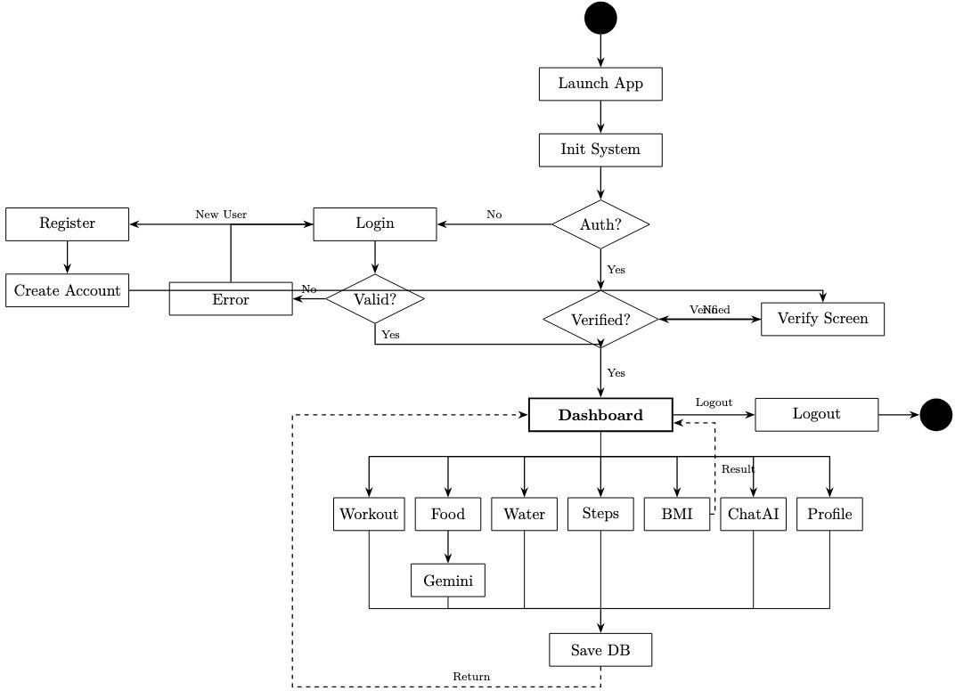

Figure 3.1: Activity Diagram

Use Case Diagram

The use case diagram illustrates the interactions between the primary actor (User) and the various system functions available in Fit Axis. Key use cases include: Register/Login, Update Profile, Calculate BMI, Log Calories, Track Water Intake, Log Steps, Log Workout, and Chat with AI Fitness Coach. The system boundary encompasses all these interactions, with Firebase serving as the external system for data persistence and authentication.

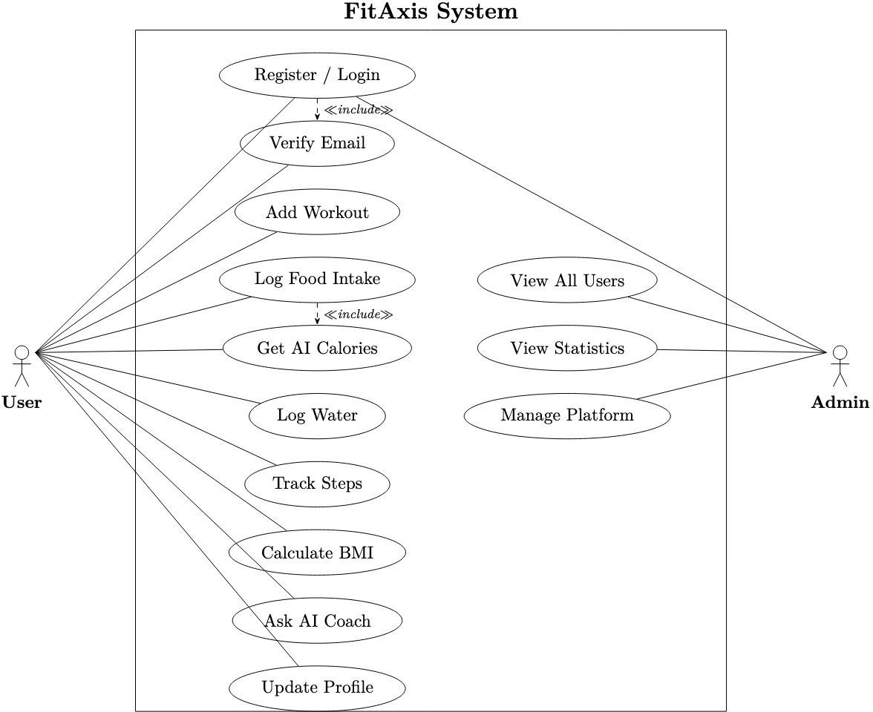

Figure 3.2: Use case diagram

ER Diagram

The Entity-Relationship (ER) diagram presents the data model for the Fit Axis application. The main entities are: User (userId, name, age, gender, height, weight, email), CalorieLog (logId, userId, foodName, calories, servings, timestamp), WaterLog (logId, userId, amount_ml, timestamp), StepLog (logId, userId, steps, caloriesBurned, timestamp), WorkoutLog (logId, userId, workoutType, duration, caloriesBurned, timestamp), and AIChat (chatId, userId, messages, timestamp). All logs are related to the User entity via a one-to-many relationship through the userId foreign key.

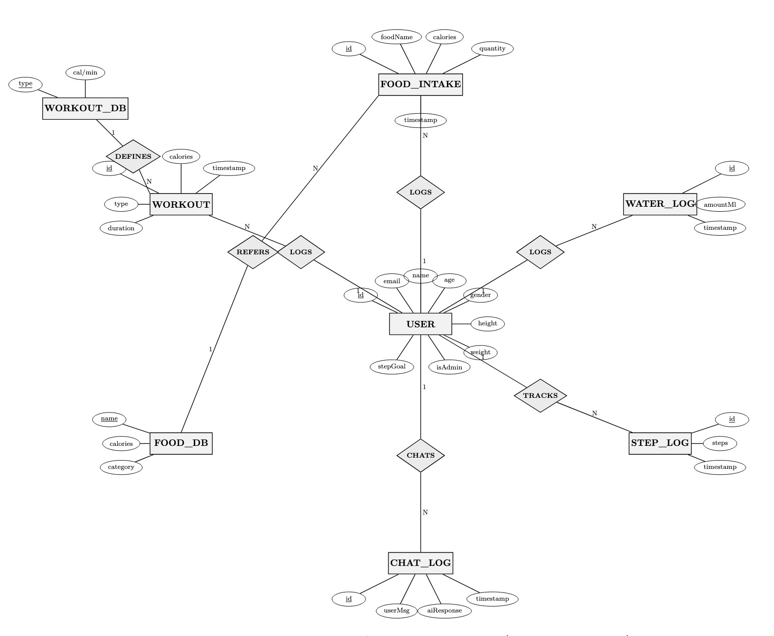

Figure 3.4: ER diagram

Data Flow Diagram

DFD-0 (Context Diagram): At the context level, the Fit Axis system accepts inputs from two sources: the User (fitness data, profile information, chat messages) and the Gemini AI API (AI- generated responses). The system outputs health summaries, fitness logs, and AI coach responses back to the user. Firebase Firestore serves as the external data store.
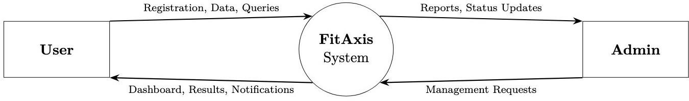

Figure 3.4: DFD diagram level 0

DFD-1 (Level 1): At the first level of decomposition, the system is broken down into six major processes: (1) User Authentication, (2) Profile Management, (3) Fitness Data Logging (covering calories, water, steps, and workouts), (4) BMI Calculation, (5) AI Coaching, and (6) Dashboard & Reporting. Data flows between these processes and the Firebase data store.

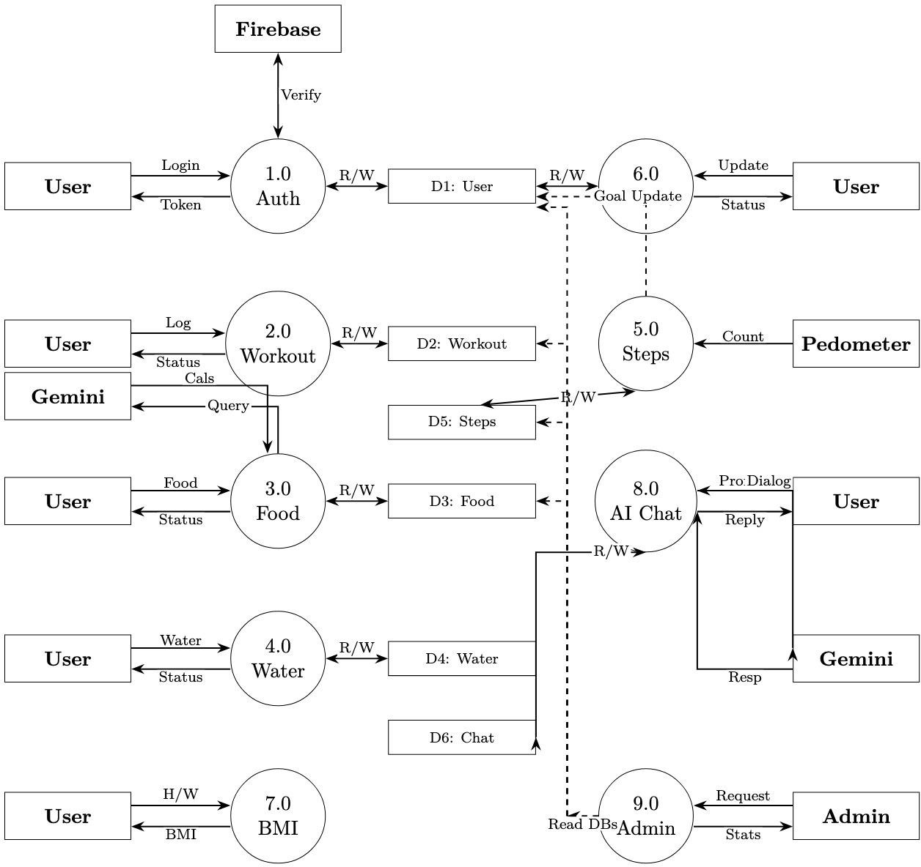

Figure 3.5: DFD diagram level 1

Chapter 4: Accomplishment

This chapter describes how the Fit Axis project was planned and executed, detailing the tools and technologies used, the development approach followed, and how each module was built and integrated.

Preliminaries
    - Before development began, a series of preparatory steps were completed:
    - Technology Selection: Flutter was selected as the primary framework due to its cross- platform capabilities, rich widget library, and strong community support. Firebase was chosen as the backend due to its seamless Flutter integration, real-time database capabilities, and free tier availability.
    - Environment Setup: The development environment was configured with Flutter SDK (version 3.x), Android Studio, and the Dart programming language. Firebase was configured with a new project, with Authentication, Firestore Database, and Storage services enabled.
    - API Integration Planning: The Gemini AI API was selected for the AI Fitness Coach feature. API keys were obtained and the integration was planned using HTTP request handling within Flutter.
    - UI/UX Design: Wireframes were sketched for each screen of the application, establishing a consistent color scheme of olive green, dark navy, and white, which was then implemented throughout the application.

The following table presents the key user data fields managed within the Profile module:

Field | Data Type | Description
Name | String | Full name of the user
Age | Integer | Age of the user in years
Gender | String | Male, Female, or Other
Height (cm) | Double | User's height in centimeters

Field | Data Type | Description
Weight (kg) | Double | User's weight in kilograms
Email | String | Registered email address

4.2How the Work Was Done

The development of Fit Axis was divided into phases corresponding to each major module of the application:

Phase 1 — Authentication & Profile Module
Firebase Authentication was integrated to handle user registration and login with email and password. Upon first login, users are prompted to complete their profile by entering personal details. Profile data is stored in Firebase Firestore under a Users collection, with each document keyed by the user's unique Firebase UID. A profile edit page was developed allowing users to update their information at any time, as well as toggle dark mode.

Phase 2 — BMI Calculator
The BMI Calculator screen uses two slider inputs for height (in cm) and weight (in kg). Upon tapping the Calculate BMI button, the app computes BMI using the standard formula: BMI = weight (kg) / (height (m))^2. The result is displayed with a health classification (Underweight, Normal Weight, Overweight, or Obese) color-coded in green, yellow, or red for intuitive interpretation.

Phase 3 — Calorie Tracker
The Calorie Tracker module allows users to log food items with their estimated caloric value and serving size. Logged items are stored in Firestore under a CalorieLogs subcollection for each user. The screen displays a daily calorie summary at the top, along with a scrollable list of logged meals for the current date. Users can delete entries by tapping the trash icon. A daily calorie goal is set based on the user's profile data.

Phase 4 — Water Intake Tracker
The Water Intake module records water consumption in milliliters. Users can add new entries using the floating action button, which prompts a dialog to enter the amount. Entries are stored in Firestore with timestamps and displayed in a chronological list. Future versions of the app

will include a daily goal tracker with a visual progress bar.

Phase 5 — Steps Tracker
The Steps Tracker displays a circular progress indicator showing steps logged against a 10,000- step daily goal. Users can manually log step counts, and the module calculates estimated calories burned based on the user's weight. A step history section shows all logged entries for the day, with a swipe-to-delete function.

Phase 6 — Workout Logger
The Workout Logger allows users to select a workout type from a predefined list (Cycling, Running, Swimming, Push-ups, Stretching, etc.) and enter the duration in minutes. The system automatically calculates estimated calories burned using MET (Metabolic Equivalent of Task) values associated with each workout type. Logged workouts are saved to Firestore and displayed with date and calorie burn information.

Phase 7 — AI Fitness Coach
The AI Fitness Coach feature was implemented by integrating the Gemini AI API via HTTP POST requests from Flutter. The chat interface mimics a messenger-style UI with sent and received message bubbles. When a user submits a question, the app sends the message to the Gemini API along with a system prompt defining the AI's role as a fitness coach. The response is parsed and displayed in the chat window. Chat history is optionally stored in Firestore to allow users to review past conversations.

Phase 8 — Home Dashboard & Activity Summary
The Home Dashboard provides an overview of the user's daily progress, including remaining calories, steps taken, water consumed, and quick links to all modules. The Activity Summary screen displays a weekly bar chart of calories burned and a Calorie Balance card showing intake versus expenditure. This screen was built using the fl_chart Flutter package for data visualization.

Chapter 5: Results

This chapter presents the results of the Fit Axis project. The application was successfully implemented as a fully functional Android application with all planned features operational. The following sections provide a technical and functional description of the system, along with screenshots of the key interfaces.

Technical Description
Fit Axis is built using the following technology stack:
    - Frontend Framework: Flutter 3.x with Dart programming language
    - Backend: Firebase Authentication, Firebase Firestore (NoSQL real-time database)
    - AI Integration: Google Gemini AI API via RESTful HTTP requests
    - Charts and Visualizations: fl_chart Flutter package
    - State Management: Flutter setState and StreamBuilder for real-time data
    - Development Tools: Android Studio, VS Code, Git
    - Testing Platform: Android 12 (physical device) and Android Emulator

The application consists of over 20 Dart files organized into a modular structure with separate files for each screen, service layer (Firebase handlers), model classes, and utility functions. The total codebase comprises approximately 3,500 lines of Dart code.

Functional Description
All ten functional requirements outlined in Chapter 3 were successfully implemented and verified:
    - User authentication with email/password via Firebase is fully functional.
    - Profile management with all user fields is operational with data persisted to Firestore.
    - The BMI Calculator correctly computes and classifies BMI based on user inputs.
    - The Calorie Tracker successfully logs, displays, and calculates daily caloric intake.
    - The Water Intake Tracker records and displays water consumption logs with timestamps.
    - The Steps Tracker accurately tracks step counts and calculates calories burned.

    - The Workout Logger supports multiple workout types and correctly estimates calorie expenditure.
    - The AI Fitness Coach successfully communicates with the Gemini AI API and provides contextual fitness advice.
    - The Activity Summary dashboard correctly displays weekly calorie burn charts and calorie balance data.
    - Dark Mode toggle is functional and applied system-wide through Flutter's ThemeMode.

User Interface Screenshots
The following screenshots demonstrate the key screens of the Fit Axis application as captured on an Android test device:
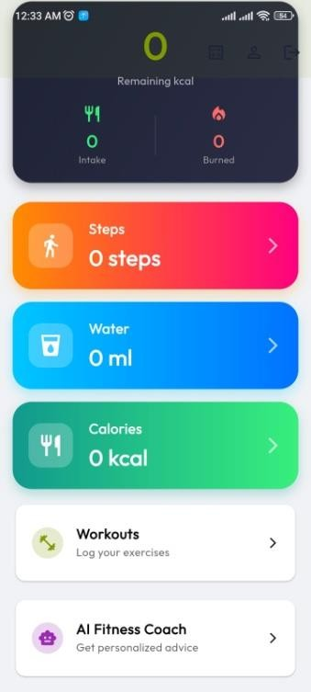
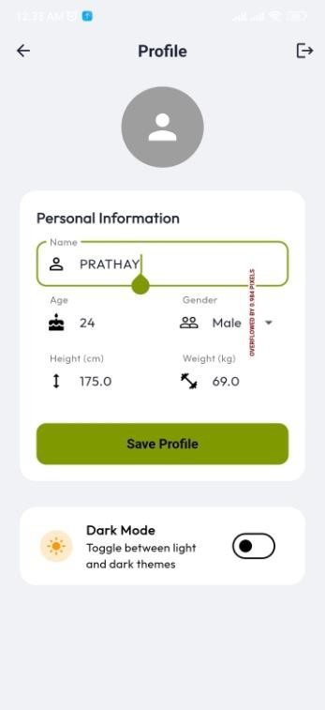
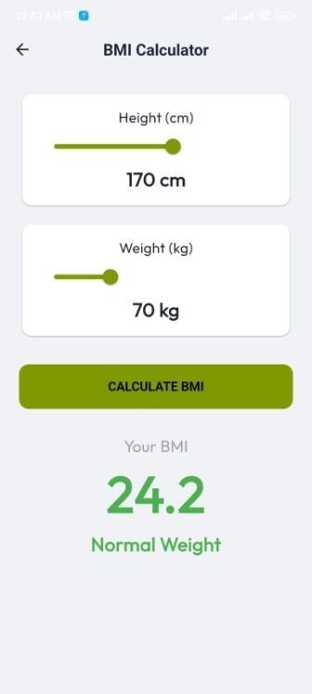
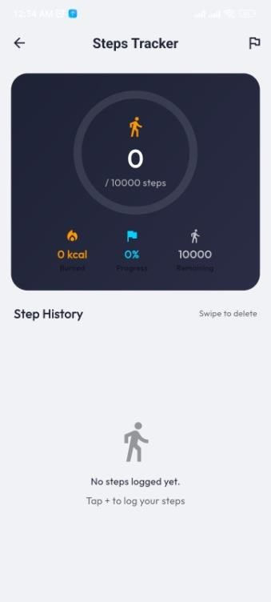
Fig-5.3.1: Home Dashboard Fig-5.3.2: User Profile Fig-5.3.3: BMI Calculator Fig-5.3.4: Steps Tracker

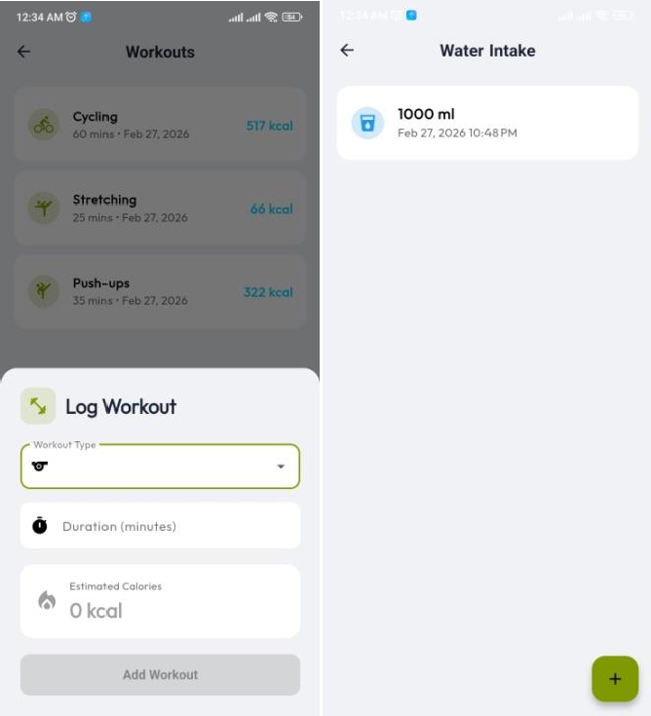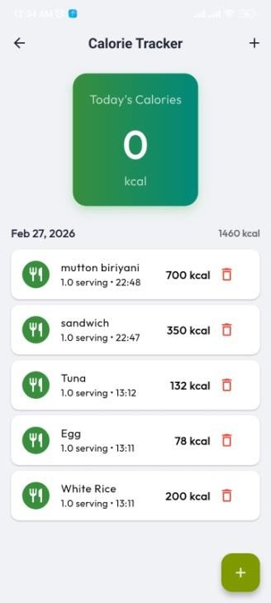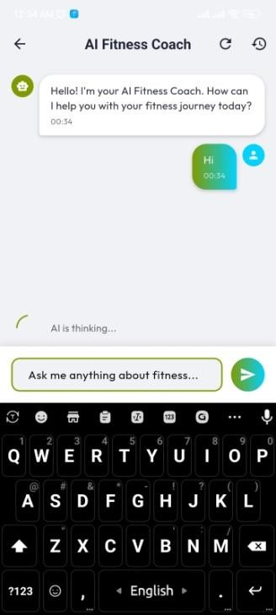

Fig-5.3.5: Workouts Fig-5.3.6: Water Intake Fig-5.3.7: Calorie Tracker Fig-5.3.8: AI Fitness Coach

Fig-5.3: Screenshot of Fit Axis

5.4 Testing
The application was tested through functional testing across all modules on an Android 12 device. Each feature was verified against its corresponding functional requirement. The following observations were noted:
- All CRUD operations (create, read, update, delete) on Firestore data work correctly with real-time synchronization.
- Firebase Authentication correctly handles registration, login, logout, and session persistence.
- The AI Fitness Coach responds within 2-4 seconds on a Wi-Fi connection, meeting the performance requirement.
- Dark mode is correctly applied across all screens without any UI rendering issues.
- The BMI classification logic was verified against WHO BMI classification standards.
- Calorie burn calculations for workout types were validated against published MET value tables.

Chapter 6: Conclusion
This chapter presents the conclusions drawn from the development and testing of the Fit Axis application, discusses the achievements relative to the original goals, and outlines the restrictions, limitations, and potential directions for future work.
The Fit Axis project successfully achieved its primary objective: the development of a comprehensive, AI-powered mobile fitness tracking application using Flutter and Firebase. All ten functional requirements were implemented and verified during testing. The application delivers a clean and intuitive user experience and has demonstrated reliable performance on Android devices.
The integration of the Gemini AI API as the backbone of the AI Fitness Coach feature represents a significant accomplishment, providing users with contextual, personalized fitness advice that goes beyond what static rule-based systems can offer. The modular architecture of the application ensures that individual features are independently maintainable and extensible.
.

Restrictions

The following restrictions apply to the current version of Fit Axis:
    - The application is currently only available on Android. iOS support, while technically feasible with Flutter, was not tested or deployed due to the absence of a macOS development machine and an Apple Developer account.
    - The AI Fitness Coach requires an active internet connection to query the Gemini API and cannot function offline.
    - User data is stored in Firebase Firestore. Access to data depends on network connectivity; there is no offline caching mechanism implemented at this stage.
    - The calorie database relies on user-entered values and predefined estimates. It does not integrate with an official nutritional database API.

Limitations

Beyond the above restrictions, the following limitations were identified during development and testing:
    - Step counting is currently manual — users must self-report their step count. An automatic pedometer integration using the device accelerometer was planned but could not be completed within the project timeline.
    - The application does not yet support social features such as sharing achievements, competing with friends, or joining group fitness challenges, which are key engagement drivers in popular fitness apps.
    - Nutritional data (macronutrients such as proteins, fats, and carbohydrates) is not tracked. Only total caloric intake is recorded.
    - The weekly activity chart on the Activity Summary screen requires sufficient logged data to be meaningful. New users will see empty charts initially.
    - There is currently no push notification system to remind users to log their meals, water, or workouts.

Future Work

Based on the limitations identified above, the following enhancements are proposed for future development:
    - Automatic Step Detection: Integrate Flutter's accelerometer or pedometer plugins (e.g., pedometer package) to automatically count steps in real time without manual input.
    - Push Notifications: Implement Firebase Cloud Messaging (FCM) to send daily reminders and motivational messages to users.
    - Nutritional Database Integration: Integrate a third-party nutritional API (such as Open Food Facts or Nutritionix) to allow users to search for foods and automatically retrieve accurate nutritional data.

    - iOS Deployment: Deploy the application to the Apple App Store using Xcode and an Apple Developer account.
    - Social Features: Add friend-connecting, leaderboards, and shared workout challenges to increase user engagement and motivation.
    - Offline Support: Implement Firestore offline persistence to allow users to log data without an active internet connection, syncing when reconnected.
    - Macronutrient Tracking: Expand the calorie tracker to record proteins, fats, and carbohydrates, and display a breakdown pie chart on the dashboard.
    - Wearable Integration: Explore integration with smartwatches and fitness bands via Bluetooth to automatically sync health data.
.

References

[1] MyFitnessPal, Inc. MyFitnessPal — Calorie Counter & Diet Tracker. https://www.myfitnesspal.com (visited 2025-09-01).
[2] Google LLC. Google Fit — Activity Tracking. https://www.google.com/fit (visited 2025-09-01).
[3] Samsung Electronics Co., Ltd. Samsung Health. https://www.samsung.com/global/galaxy/apps/samsung-health (visited 2025-09-01).
[4] Cronometer Software Inc. Cronometer — Track Nutrition & Count Calories. https://cronometer.com (visited 2025-09-01).

Appendix A: User’s Guide

This section provides step-by-step instructions to help users install, configure, and operate the Fit Axis application.

Installation and Setup
  - Download the Fit Axis APK file from the provided link or scan the QR code provided by the development team.
  - On your Android device, go to Settings > Security and enable 'Install from Unknown Sources' if not already enabled.
  - Open the downloaded APK file from your device's file manager and tap 'Install'.
  - Once installation is complete, open the Fit Axis app from your home screen.

Registration and Login
  - On the Welcome Screen, tap 'Register' to create a new account.
  - Enter your email address and a secure password, then tap 'Sign Up'.
  - You will be prompted to complete your profile. Enter your name, age, gender, height, and weight, then tap 'Save Profile'.
  - On subsequent launches, enter your registered email and password and tap 'Login'.

Using the Home Dashboard
The Home Dashboard is the central hub of Fit Axis. It displays your remaining calorie budget for the day, along with quick-access cards for Steps, Water, Calories, Workouts, and AI Fitness Coach. Tap any card to navigate to the corresponding module.

Logging Food (Calorie Tracker)
  - From the Home Dashboard, tap the 'Calories' card.
  - Tap the '+' floating action button at the bottom right of the screen.
  - Enter the food name and estimated calories, then tap 'Add'.
  - The food item will appear in your daily log with a timestamp. Tap the trash icon to delete an entry.

Using the AI Fitness Coach
  - From the Home Dashboard, tap 'AI Fitness Coach'.
  - Type your fitness question in the input field at the bottom of the screen.
  - Tap the send button (green arrow). The AI will respond within a few seconds.
  - You may ask follow-up questions to continue the conversation. Tap the refresh icon to start a new session.

Logging Workouts
  - From the Home Dashboard, tap 'Workouts'.
  - A log workout sheet will appear. Select a workout type from the dropdown menu.
  - Enter the duration in minutes. The system will automatically calculate estimated calories burned.
  - Tap 'Add Workout' to save the entry.

For further assistance or to report issues, please contact the development team at the Department of CSE, Leading University, Sylhet.

